Coordination of threads
normally we can’t manage the thread status directly.
We could have thread that collaborate each other.
Locks can’t be used for thread coordination.
The solution is the barrier, that is active until all task reach that.
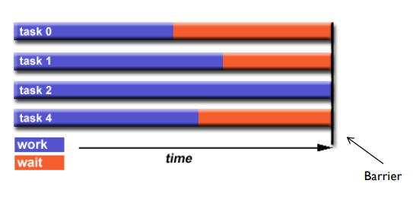
Wait(), notify(), notifyAll()
Wait: the thread leave the intrinsic lock acquired and wait until it not receive a notify of wake up.

Notify(): wakes up the first threads that called wait().

NotifyAll(): wakes up all threads that called wait inside synchronized block or method that use intrinsic lock.

The call of all methods must be done inside a synchronized or intrinsic lock method.

Wait must be called inside try catch with InterruptedException catch block.
Wait must called on the object that call notify.

If there is IllegalMonitorStateException you are using a not correct lock

wait must called in the case of a condition is verified, USE the following implementation

while(!condition){
wait();
}

while is mandatory, because it can manage is condition is acceptable and put on wait status thread that don’t wake up in that moment, because we use notifyAll that wake up all waiting threads on that object..
notify is rarely used. NotifyAll is most used with wait.

Why used synchronized to call wait and notify
these methods must be coordinate on a common object, give correct visibility.
These need to modify and verify flags.

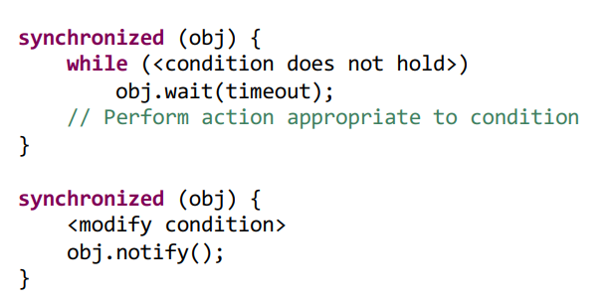
Be careful
the wait operation forces the thread to release the lock before going to sleep-
Release of the lock is mandatory to avoid deadlock!!!!

There is an alternative to use with reetrant locks.

Lock.newCondition() create a Condition object that has await() method to put in the same while of the previous solution.
Signal() wake up the threads.
This solution allows to have more communication channels for threads.

Synchronizer
they are a concurrent building blocks useful for coordinating the flow of execution of concurrently executing threads.
- Thread ask to synchronizer to check internal state
- According to the internal state the synchronizer forces the thread to wait or let it pass
- The synchronizer provides methods for other threads to manipulate the state

Queues
they are FIFO, these queues haven’t blocking system if it empty it will return null
Blocking queues : block when the queue is empty and when the queue is full.

Blocking queues are useful to implement the producer-consumer design pattern
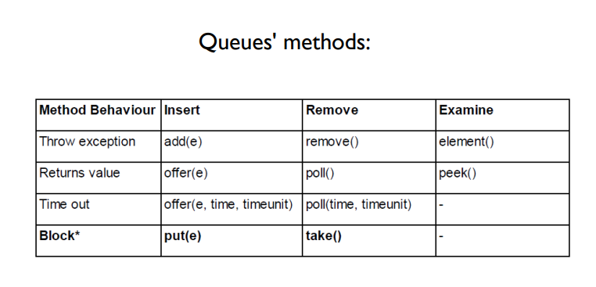
-

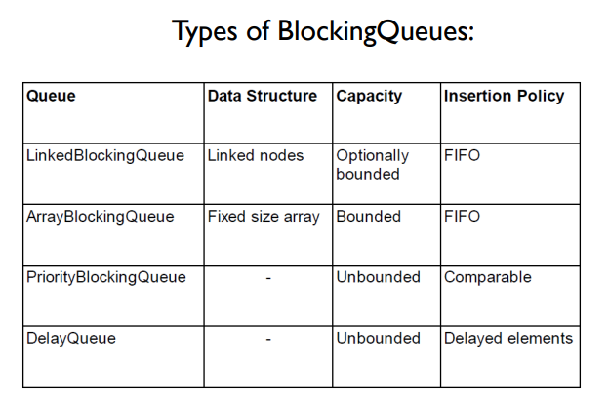
blockingqueue put wait the thread if queue is empty, or full if bounded.

SynchronousQueue
it is a queue without capacity that allow pass a data between thread and if there is no data, it put thread in wait until data arrives.
Take and put methods resolve visibility, wait and notify ecc.
It allow to have alternation between thread.
Semaphore
it is useful to manage the access to an shared resource.
It release n virtual access permissions via acquire() and release().
Semaphore can manage accesses to resource with limit access available.

- CountDownLatch: threads have to wait until the latch reaches its terminal state. Similar to a door. Example of use: to simultaneously start the execution of threads.
- CyclicBarrier: similar to the CountDownLatch, but it is possible to reset it for reuse.
- Exchanger: allows threads to exchange objects at a rendez-vous. Blocks until another thread calls exchange(). Useful for sharing data buffers. Similar behaviour of the SynchronousQueue.
- Phaser: similar functionality to CountDownLatch and CyclicBarrier, but more flexible. If there’s the need to wait hat a thread completes some work before continuing with other operations, the phaser is an ideal solution.

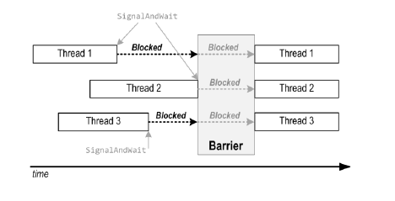

Arrive() unlock as soon as a thread end and raise the memory barrier, so we can use shared values using not concurrent elements.
More info: https://www.youtube.com/watch?v=J3QZ5gfCtAg

Scheduling in operating systems
Scheduling of processes and threads is one of the main functionalities of the operating system.
Preemptive scheduling
it a solution for time-sharing. It used because OS must be fair in scheduling.
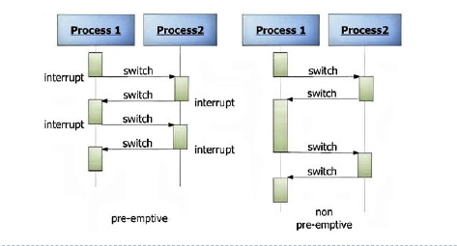

A thread can be execute for some time and then an hardware interrupt stop the process and leaves an other thread to run.
In preemptive scheduling, the scheduler assigns to each thread a fraction of the execution time called the time-slice.
At the end of each time-slice the thread execution can be suspended by the scheduler.
When suspended, the thread is forced to pause the execution by performing a context-switch.
There are 3 type of scheduler in the OS:
- Long-term scheduler: responsible to select which process is accepted for execution and with which priority.
- Medium-term scheduler: temporarily removes processes from the main-memory and saves them to disk ("swap out") – in particular processes that are not running.
- Short-term scheduler(CPU scheduler):select which process/thread is allowed to execute

Dispatcher: is the module that takes care of assigning the CPU control to the processes/threads. It is responsible for context-switches.

Short-term scheduler can be preemptive or non preemptive.
Scheduling disciplines:
- FIFO: not fair (first in first out)
- Round-robin:alternate execution for a fixed time assign to each thread
- Fixed-priority preemptive: scheduler organizes the execution of the processes/threads according to their priorities.

Java’s scheduling depends by operative system.
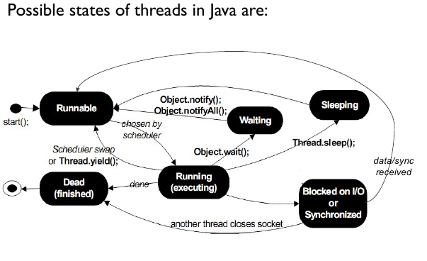
Thread not always use all time-slice.
Yield() is an instruction that allow to active the scheduler in an explicit way, often used in non preemptive solutions.
- No time-slicing and no yield() calls: just one thread runs to completion at a time.
- No time-slicing and yield() calls: cooperative scheduling, threads voluntarily exchange the execution control.
- Time-slicing and no yield() calls: threads are scheduled preemptively and at locks, sleep(), ...
- Time-slicing and yield() calls: similar to the previous one, but with additional scheduling possibilities at yield(). yield() is used to facilitate the scheduling.

An alternative to yield is priority of threads
default priority is 5.
1 Thread aThread = Thread. currentThread();
2 int currentPriority = aThread.getPriority();
3 aThread.setPriority(currentPriority + 1);
the effect of priority can differ depending on the execution platform.

Usually, larger priorities are used for threads that block frequently (sleeping or waiting for I/O), and medium/low priorities for threads that are CPU-intensive (to avoid saturation of the cores).
Stopping threads
A Java application only completes when all its (non-deamon) threads have completed.
There is a method interrupt() it assign true to a boolean flag called interrupt status.
We can have the value using interrupted()() or isInterrupted().

Thread.interruputed() is a static method. Returns the value of the flag for the thread that is active at that moment(current thread) and clears the flag (set the value to ‘false’). At the practical level, is used by the running thread to understand if an interruption has been requested and to stop the execution if needed.

Less used:
isInterrupted() is an instance method that leaves the value of the flag unmodified. Can be used by other threads to understand if an interruption has been requested for a specific thread.

Every call to the interrupt() method for a thread waiting or sleeping, forces the thread to exit the
waiting/sleeping phase by generating an InterruptedException.

InterruptedException clears the interrupt status flag.

